**Project Design Phase-I**

**Solution Architecture**

|  |  |
| --- | --- |
| Date | 19 September 2022 |
| Team ID | PNT2022TMID00684 |
| Project Name | Project - Intelligent Vehicle Damage Assessment & Cost Estimator for Insurance Company |
| Maximum Marks | 4 Marks |

**PROJECT DESCRIPTION:**

Nowadays, a lot of money is being wasted in the car insurance business due to leakage claims. Claims leakage Underwriting leakage is characterized as the discrepancy between the actual payment of claims made and the sum that should have been paid if all of the industry's leading practices were applied. Visual examination and testing have been used to may these results. However, they impose delays in the processing of claims.

The aim of this project is to build a VGG16 model that can detect the area of damage on a car. The rationale for such a model is that it can be used by insurance companies for faster processing of claims if users can upload pics and the model can assess damage( be it dent scratch from and estimates the cost of damage. This model can also be used by lenders if they are underwriting a car loan, especially for a used car.

**Solution Architecture:**

To automate such a system, the easiest method would be to build a Convolution Neural Network model capable of accepting images from the user and determining the location and severity of the damage. The model is required to pass through multiple checks that would first ensure that given image is that of a car and then to ensure that it is in fact damaged. These are the gate checks before the analysis begins. Once all the gate checks have been validated, the damage check will commence. The model will predict the location of the damage as in front, side or rear, and the severity of such a damage as in minor, moderate or severe.

The model accepts an input image from the user and processes it across 4 stages:

1. Validates that given image is of a car.
2. Validates that the car is damaged.
3. Finds location of damage as front, rear or side
4. Determines severity of damage as minor, moderate or severe

The model can also further be imporved to:

1. Obtain a cost estimate
2. Send assessment to insurance carrier
3. Print documentation

**PROCEDURE:**

* Data Collection.
* Collect the dataset or create the dataset
* Data Pre-processing.
* Import the Image Data Generator library
* Configure Image Data Generator class
* Apply Image Data Generator functionality to Train set and Test set
* Model Building
* Import the model building Libraries
* Initializing the model
* Adding Input Layer
* Adding Hidden Layer
* Adding Output Layer
* Configure the Learning Process
* Training and testing the model
* Save the Model
* Application Building
* Create an HTML file
* Build Python Code

**Example - Solution Architecture Diagram:**

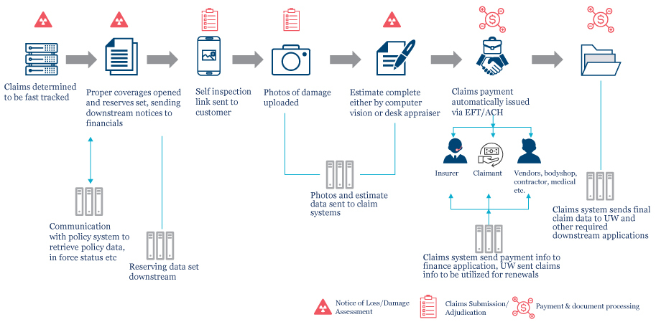

Figure 1: Architecture for the - Intelligent Vehicle Damage Assessment & Cost Estimator for Insurance Compan